## **Introduction**

1. spring.io dependencies
2. <https://start.spring.io/>
   * Spring web
   * Spring security
   * Spring boot dev tools
   * postgreSQL driver

## **Test spring boot project**

1. Create dummy controller
   * Use annotations RestController for now
   * Use GetMapping
   * And return word for now “Welcome to Spring Boot”

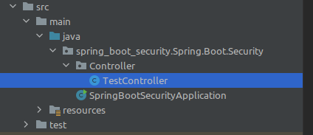

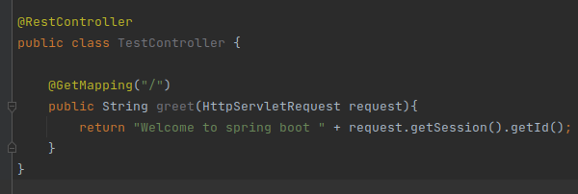

1. By default, it will show a login UI provided by Spring Boot

But if you comment out the Spring Boot security dependency, it will show the default page, which means our controller is not being guarded.

1. **Password** will appear on console, **username** = user.
2. Now run the project and test it

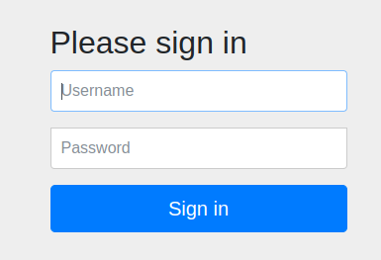

Note: we will not see this page if we disable security dependency on **pom.xml**

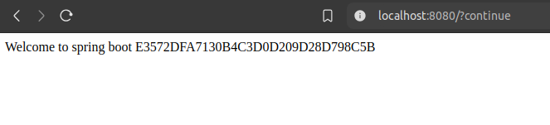

## **How are we seeing the login page when we request for the default page ?**

**Request Processing Flow:**

* When you access a controller in a web application, your request typically goes through:
  + **Filter Chain:** Filters intercept the request before it reaches the controller. These filters can perform tasks like authentication, logging, or request modification.
  + **Front Controller:** In frameworks like Spring MVC, the **Front Controller** is typically a DispatcherServlet. It serves as the central entry point for all incoming requests, delegating them to the appropriate controller.
* After the request is processed by the controller, the response follows the reverse path:
  + The response is processed by any filters (in reverse order) before being sent back to the client.

**Authentication and Validation:**

* If authentication or validation (e.g., checking the email and password) fails, the application (or filter) sends an appropriate response, such as an error message or a redirection to a login page. This can happen:
  + **In Filters:** If the filters are responsible for authentication, they might stop the request before it even reaches the controller.
  + **In the Controller:** If authentication or validation is done at the controller level, the controller will send the appropriate error message.

**Servlet and Tomcat:**

* These processes (filters, front controllers, and controllers) run within the **Servlet Container**, which is part of the **Tomcat Server**.
* Tomcat provides the runtime environment for Servlets and JSPs, handling tasks like managing threads, handling HTTP requests, and sending responses.

## **Change username and password & get CSRF token**

1. Go to src>main>java>resources>application.properties

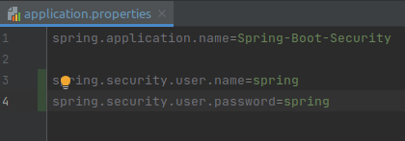

1. To get CSRF token

